hair service menu

design & style
all services include blow-dry styling. additional iron work, length and/or thickness may add $15-$30+

women’s cut $50+ blowout $35+
treatment cut $65+ iron work $50+
bang trim $15 formal style $55+
bridal style $175
color & highlight
additional color, length and/or thickness add $15-30+

gloss $50+ single process $95
touch up $75+ dual process $110
color correction on consult
partial foil $110+ dimensional partial $130+
full foil $130+ dimensional full $150+
ombré & balayage $200+
condition
botantical treatment add-on $15
botanical blowout $45+
scalp & hair treatment $65
keratin treatment $250+
men’s
men’s cut $35+ color blending $50+
neck trim $15 antidote focus facial $50
scalp treatment $30
extensions
cost varies based on hair length & thickness. consultation required prior to application
individual tape-in
volume or length $400+ volume or length $300+
full head $850+ full head $600+
antidote salon
2235 south shore center
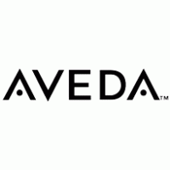
alameda ca 94501
510.523.4262 | antidotesalon.com

